INFORMATION ABOUT WEEK 1

By this time, you have been contacted directly by school personnel regarding your child/student’s participation in the CBITS group. CBITS stands for Cognitive Behavioral Intervention for Trauma in Schools. We invited your child to be part of this group because they have identified a stress or trauma and the effects of this stress or trauma is causing difficulty in one or more areas of their life. Some of these effects include:
- Irritability
- Difficulty concentrating
- Difficulty sleeping and/or nightmares
- Sadness
- Feeling jumpy/jittery

Today group members will be introduced to the Cognitive Triangle. This triangle helps illustrate how our thoughts, feelings and behaviors are all connected. Essentially how we THINK determines how we FEEL, and how we feel determines what we DO. Children who have experienced significant stress or trauma struggle even more with negative thoughts about themselves and the world around them, so it is extremely important for them to learn how to think differently to feel better. For more information about childhood trauma, visit the National Child Traumatic Stress Network website or the National CBITS program website.
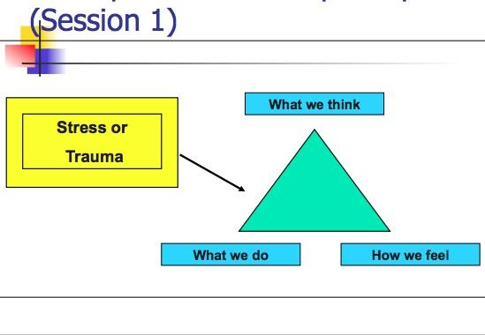

WHAT YOU CAN DO

The group will be held virtually for 10 weeks. Your child/student will have more success in the group with your help. Caregivers, you can ask about group at the end of the day. Each week, they will be given a short practice assignment to reinforce the skills or ideas they learned in the group. Ask your child/student about their assignment and help them complete it before the next group meets. The more they practice, the faster they will learn the skills that will help them recover.

This week they will be given a Goals worksheet or they may have completed it in group. Please talk about their goal for the group. You may be surprised to learn how your child is feeling. Your participation is also the best way to show your child that they are important and that you are interested and invested in their healing.

You will receive weekly letters like this one regarding what your child is doing in group. Please feel free to contact the school with any questions or concerns.

